**NAME OF THE COURSE : ARTIFICIAL INTELLIGENCE**

**NAME OF THE PROJECT : PREDICITING HOUSE PRICES USING MACHINE LEARNING**

**NAME OF THE STUDENT : R.Sujay**

**DEPARTMENT : BE-ECE**

**PHASE – 4**

Problem statement:

 The problem is to predict house prices using machine learning techniques. The objective is to develop a model that accurately predicts the prices of houses based on a set of features such as location, square footage, number of bedrooms and bathrooms, and other relevant factors. This project involves data preprocessing, feature engineering, model selection, training, and evaluation.

Phase 4 Work :

1. **Feature Selection:**

* Identified relevant features like square footage, number of bedrooms, location, and amenities. Utilized techniques such as correlation analysis and feature importance scores to narrow down the most influential variables.

1. **Model Training:**

* Implemented machine learning algorithms like Linear Regression, Decision Trees, and Random Forest. Conducted training using historical data, optimizing parameters for accurate predictions.

1. **Evaluation:**

* Utilized metrics like Mean Absolute Error (MAE), Root Mean Square Error (RMSE), and R-squared to evaluate model performance. Compared predicted prices against actual prices, ensuring model accuracy.

Source Code :

import libraries

import pandas as pd

from sklearn.model_selection import train_test_split

from sklearn.preprocessing import StandardScaler

from sklearn.linear_model import LinearRegression

from sklearn.metrics import mean_squared_error, r2_score

**# Step 1: Load the dataset**

dataset = pd.read_csv('housing.csv') # Replace 'housing.csv' with your actual dataset file name

**# Step 2: Handle Missing Values (if any)**

# For example, removing rows with missing values

dataset = dataset.dropna()

**# Step 3: Split Data into Features and Target Variable**

X = dataset.drop('target_column_name', axis=1) # Replace 'target_column_name' with the actual name of the target column

y = dataset['target_column_name']

**# Step 4: Split Data into Training and Testing Sets**

X_train, X_test, y_train, y_test = train_test_split(X, y, test_size=0.2, random_state=42)

**# Step 5: Feature Scaling**

scaler = StandardScaler()

X_train_scaled = scaler.fit_transform(X_train)

X_test_scaled = scaler.transform(X_test)

**# Step 6: Build and Train the Model (Linear Regression)**

model = LinearRegression()

model.fit(X_train_scaled, y_train)

**# Step 7: Make Predictions**

predictions = model.predict(X_test_scaled)

**# Step 8: Evaluate the Model**

mse = mean_squared_error(y_test, predictions)

r2 = r2_score(y_test, predictions)

print(f'Mean Squared Error: {mse}')

print(f'R-squared Value: {r2}')

Algorithm:

* **Random Forest Regression:**

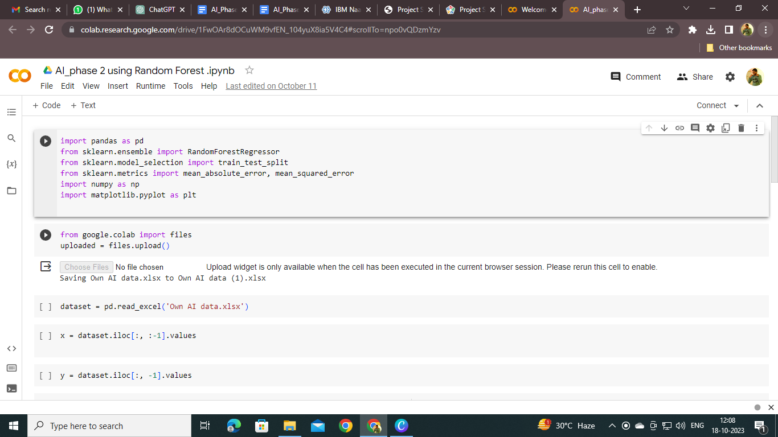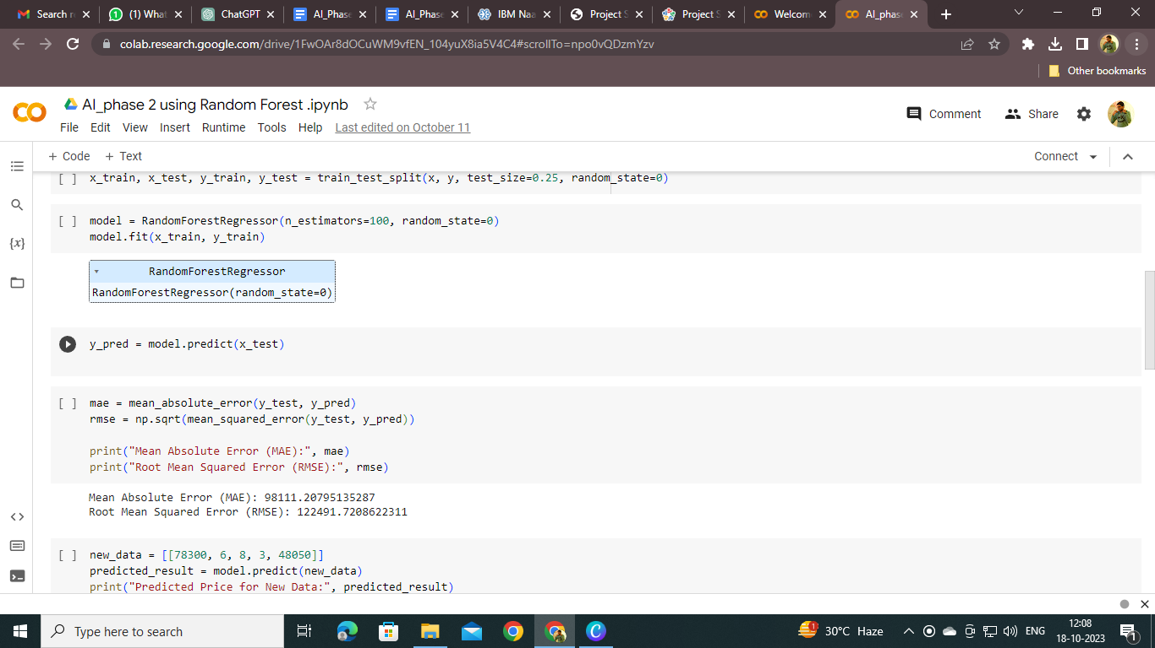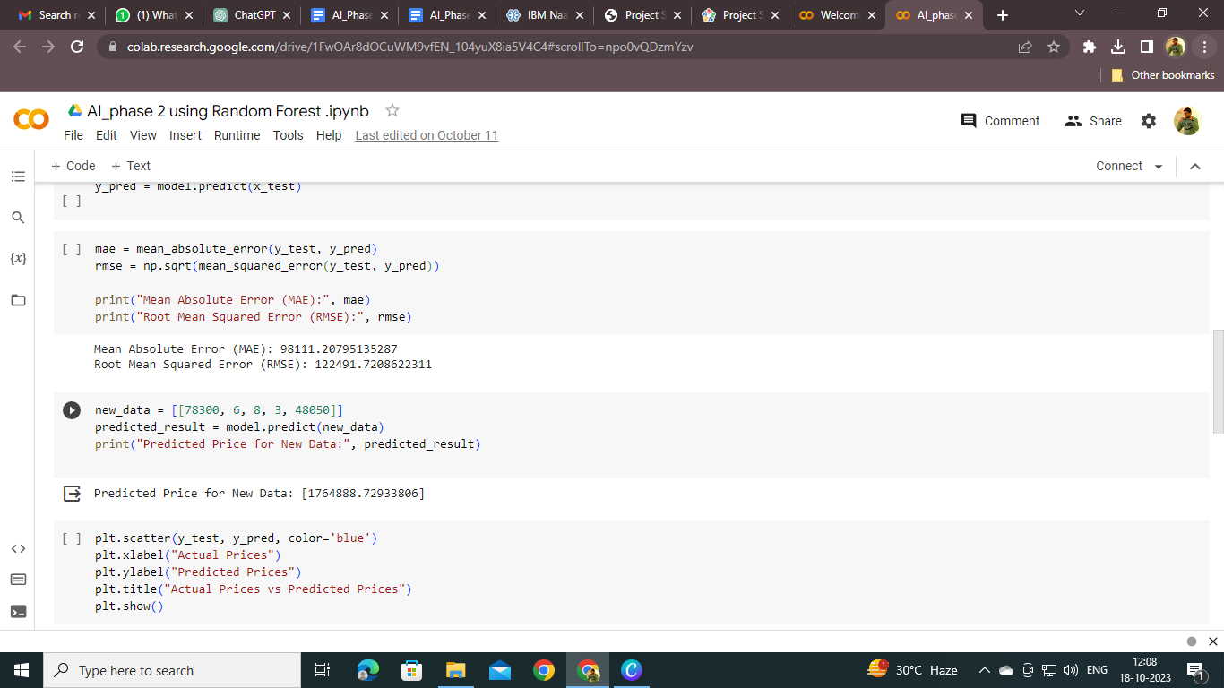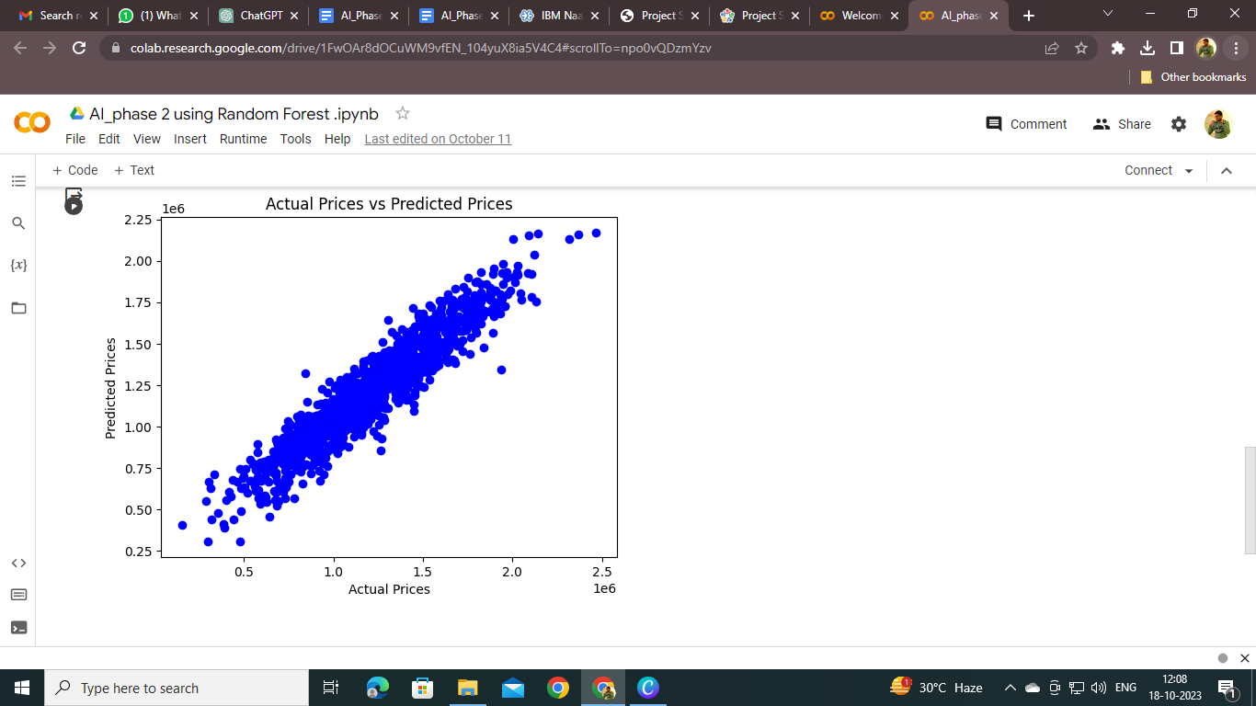

* **Linear Regression:**

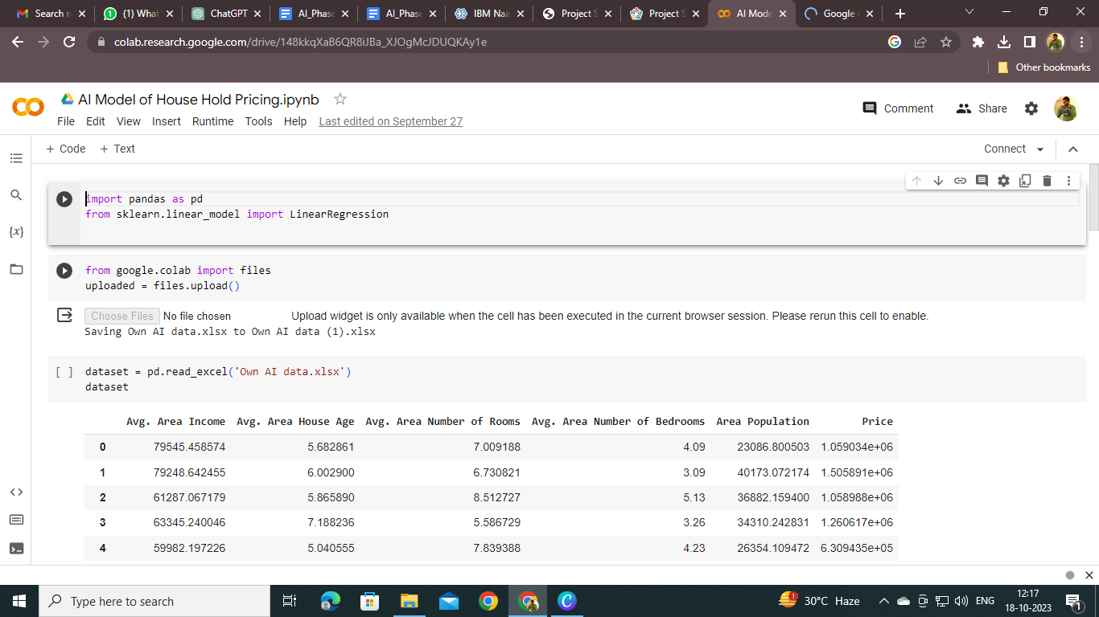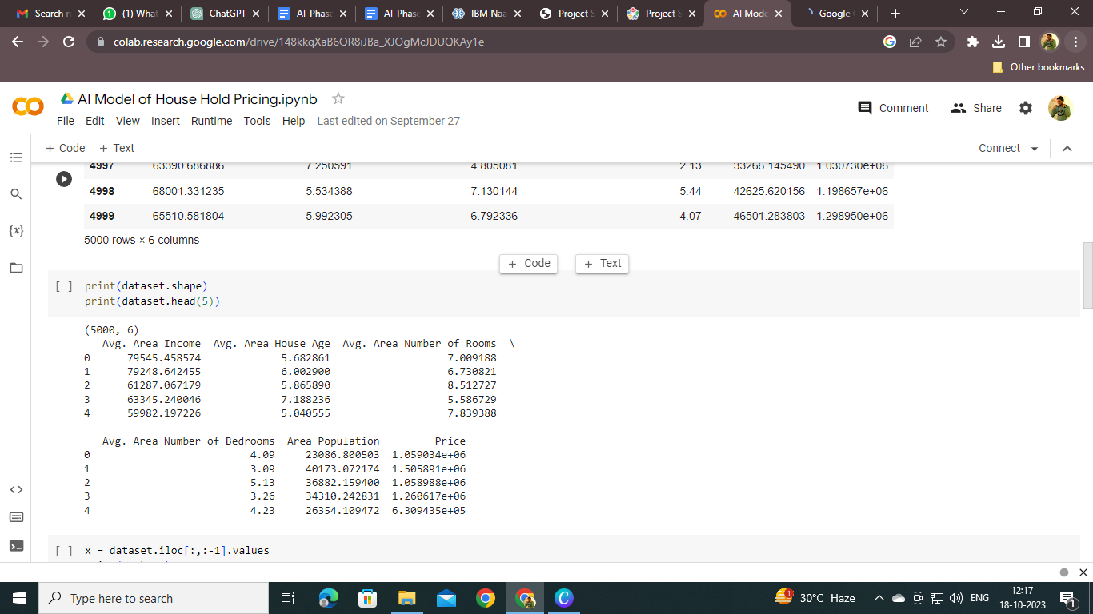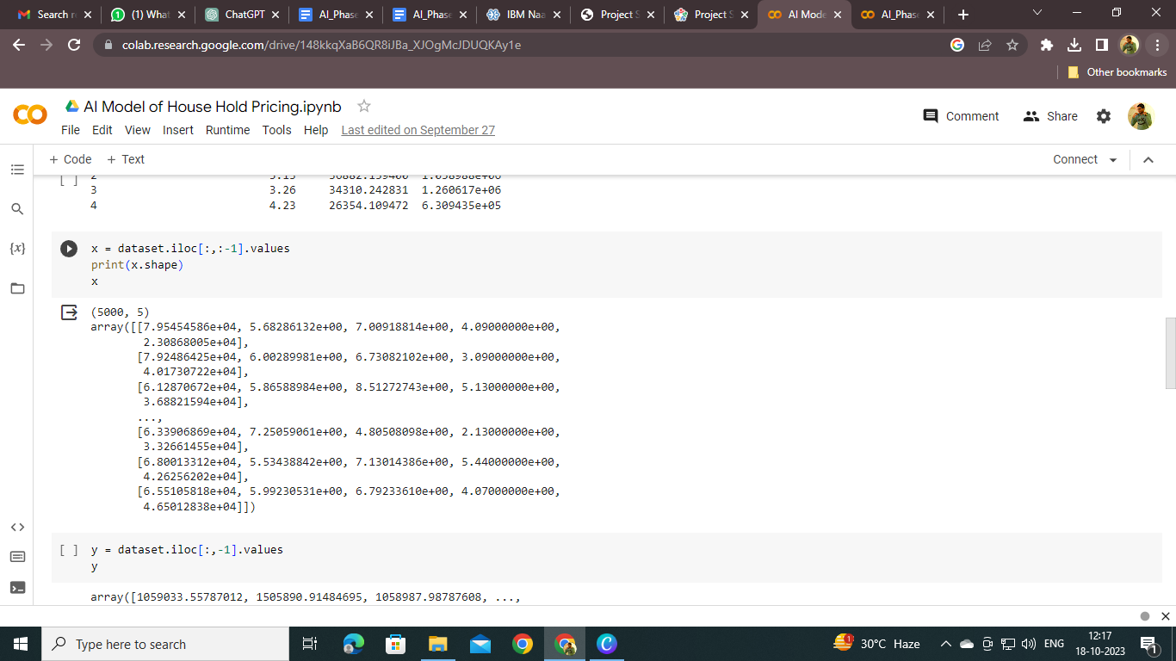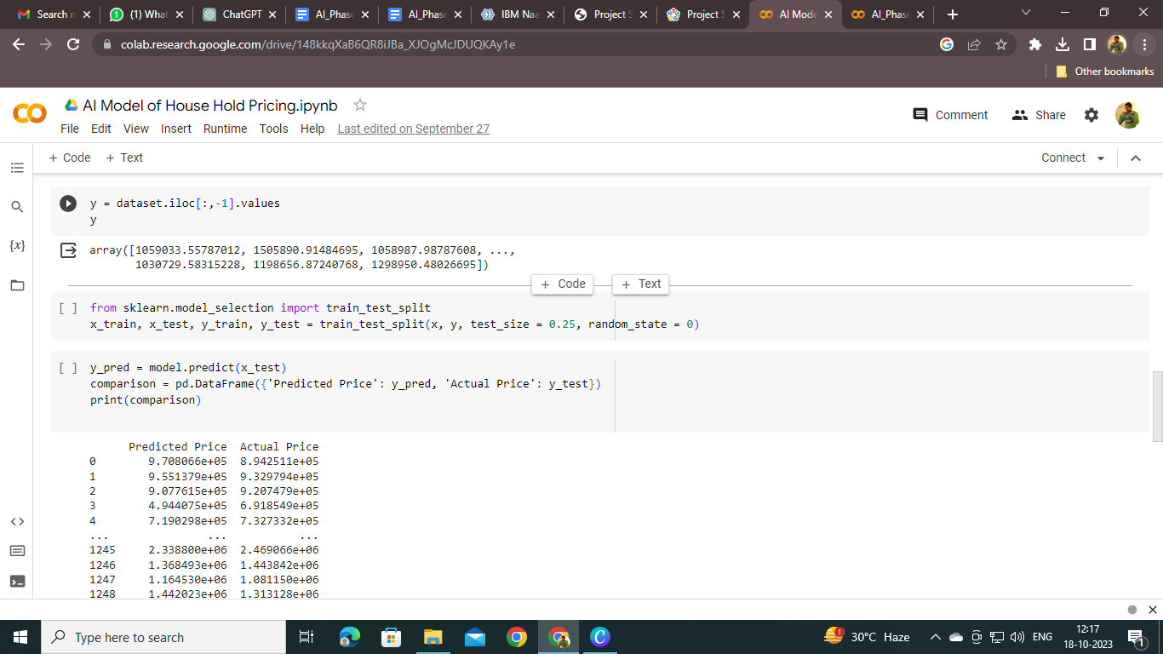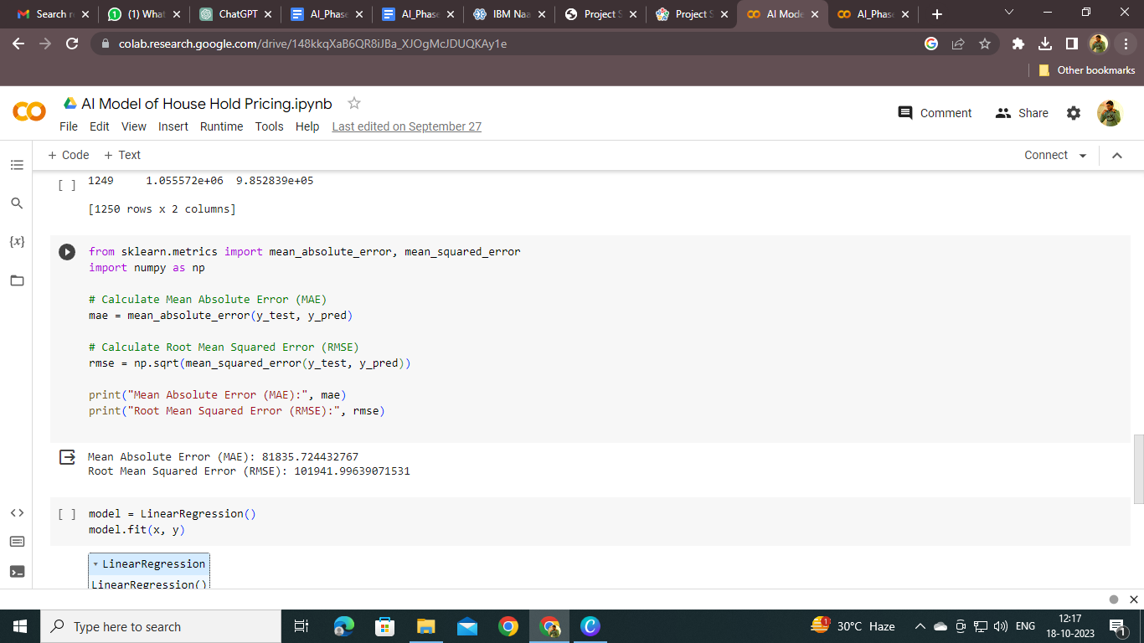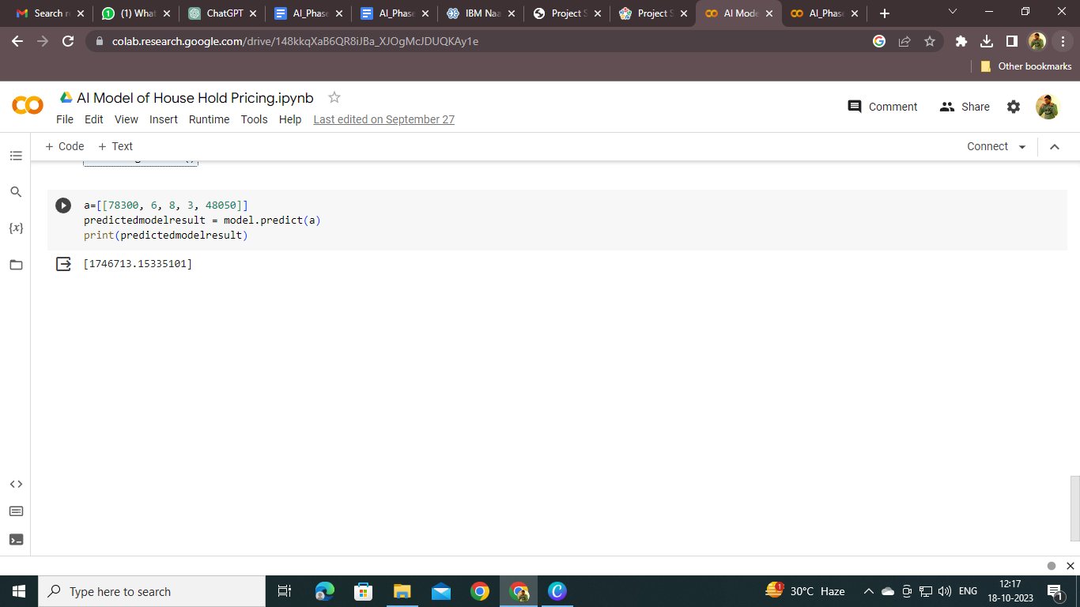

* **XG Booster:**

